**React Assignment:2**

1. **Apply the concept of conditional rendering,to display the Login Component if the user is not logged in, or display the NumberList component if he or she is logged in.**

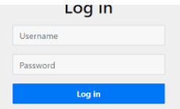

**NumberList View**

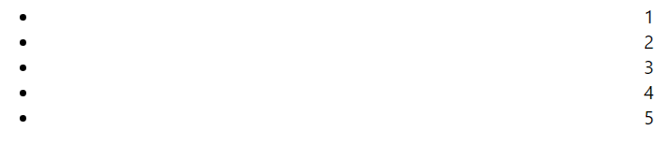

1. **Create a UI for the below State data. Create Component named TableRow that accepts state data as the props and renders each item as as a Table Row.**

**this.state = {**

**data:**

**[**

**{**

**"id":1,**

**"name":"Foo",**

**"age":"20"**

**},**

**{**

**"id":2,**

**"name":"Bar",**

**"age":"30"**

**},**

**{**

**"id":3,**

**"name":"Baz",**

**"age":"40"**

**}**

**]**

**}**